Ambassador Terry Miller

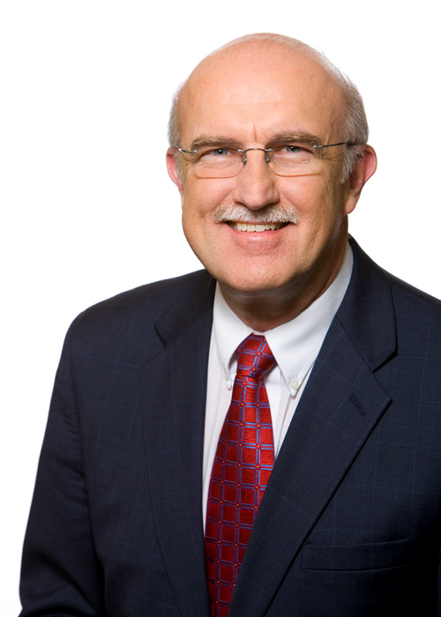
Ambassador Terry Miller is director of two of The Heritage Foundation’s key research centers, Data Analysis and Trade and Economics, and as the think tank’s Mark A. Kolokotrones fellow in economic freedom.

At the Center for Trade and Economics, Miller focuses on research into how free markets and international trade foster economic growth around the world. He is editor of a signature Heritage publication, the annual Index of Economic Freedom.

At the Center for Data Analysis, Miller oversees the statistical and econometric modeling that underpins the think tank’s wide-ranging research programs.

Both centers are part of Heritage’s Institute for Economic Freedom and Opportunity.
Director, Center for Data Analysis and the Center for Trade and Economics and Mark A. Kolokotrones Fellow in Economic Freedom

Before joining Heritage in 2007 as director of the Center for Trade and Economics, Miller had a distinguished career in the U.S. Foreign Service. In 2006, he was appointed as an ambassador to the United Nations and U.S. representative on the U.N.’s Economic and Social Council.

Miller previously served at the State Department as deputy assistant secretary for economic and global issues. He headed offices at State devoted to the promotion of human rights, social issues, development and trade.

Overseas, Miller served in Italy, France, Barbados and New Zealand. He headed the U.S. observer mission to the U.N. Educational, Scientific and Cultural Organization (UNESCO).

